# AZ300-something Notes – Chapter 2

**Azure Site Recovery:** bring on premise stuff to Azure, but if it fails in the cloud, fall back to on-premise

OMS: Backup and Site Recovery is the new name of Recovery Services Vault  
-> we can configure on premises stuff in this to fall back onto (replicate them to Azure first)

Message: we kinda know the receiver (can form the content as such)  
Event: we don’t know anything about who’ll receive it

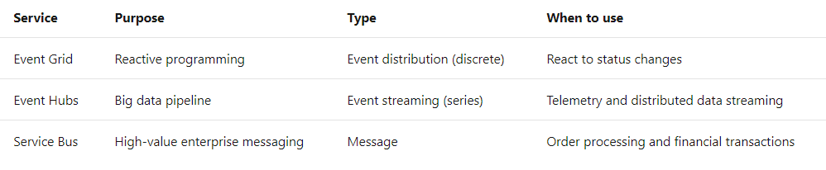

Even Grid: event-consumption service, publish/subscription model, pass info between services (eg. on premise app publishes an event and an Azure Function app listens to it)

Service Bus: messaging service (FIFO or publish/subscribe model)  
- with FIFO/queues, it’ll exchange messages with **one partner service**- with publish/subscribe: sender can push info to **any number of subscribed services**